**Lights Out Game**

**Designed and Developed By:** Graham Beesley

**Release Notes and Instructions**

* Application has been implemented as a WPF app targetting .NET Framework 4.7.2, developed using Visual Studio 2019.
* Application can be run through Visual Studio or can be installed on a Windows PC using the installer that can be found in the top level solution folder.
* On launch the application window should appear looking something like this but with a randomised arrangement of lights:

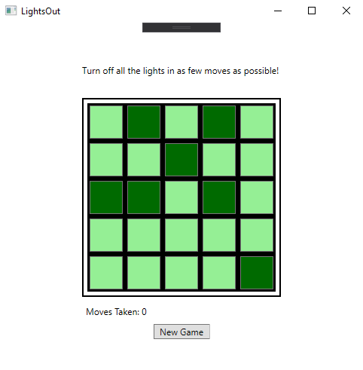

* Each click of a button/light on the grid will toggle the state of the light clicked and every orthogonally adjacent light, and increment the Moves Taken counter.
* Once every light is in the off state a ‘You’ve won!’ message box will be displayed.
* Clicking the ‘New Game’ button will create a new arrangement of lights and reset the Moves Taken count.
* To close the application click on the X in the top right hand corner.

**Testing**

* Unit tests were created for the LightGrid class to validate that the constructor and public methods function as expected, these can be found in the LightsOutTests project.
* Testing of the interface was performed manually repeatedly throughout development to confirm visual elements behaved as expected, including:
  + When a light is clicked the on/off state of that light and the adjacent lights visually toggle as expected.
  + Moves Taken count increments on each click.
  + When all lights are out the success message box is displayed.
  + On clicking ‘New Game’ a new arrangement of lights is displayed and the Moves Taken counter resets.
* Consideration of how to guarantee that the starting state of a new game would always be solvable led to the design decision to create the starting pattern of lights via emulating a randomised sequence of button presses from the all lights off state, rather than a completely randomised number and arrangement of lights that would then require further validation to confirm a solvable game.